Indiana Department of Natural Resources

Indiana Dunes State Park
N Saw-whet Owl Banding Station

Updated October 2014

PURPOSE:

The goals of the owl banding program at Indiana Dunes State Park are to:
- Monitor long-term changes in Saw-whet Owl populations
- Track timing of migration of age/sex groups along Lake Michigan’s southern shore
- Study stopover patterns and lengths
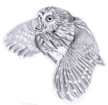
- Educate the public of migrating Saw-whet Owls

Name and address of coordinator:
Brad Bumgardner
Indiana Dunes State Park
1600 N 25 E
Chesterton, IN 46304
bbumgardner@dnr.in.gov

GENERAL METHODS:
The owl banding program is run from roughly October 1 to November 20, for 4-8 hours each night starting one-half hour after sunset. In 2013, two arrays totaling 10 nets are set up, each array in the form of a cross with one net on each side, with exception of one side with two nets. A speaker is placed in the center of the cross, connected to an mp3 player that continuously broadcasts calls of Saw-whet Owls (the principal target species). All owls captured are banded and complete banding data is recorded on forms provided, along with netting effort. Safety of the birds is paramount, and the protocol should be temporarily abandoned if safety is compromised. All protocol is done to standards made continent wide with Project Owl Net. (www.projectowlnet.org)
DETAILED PROTOCOL FOR STANDARD COVERAGE PERIOD:
1. Criteria for operation
In general, banding should occur on all suitable nights between October 1 and November 20.
Aside from the principal licensed bander, a minimum of two qualified people per night is recommended for each station (both experienced in extracting owls from nets). If no one else is available, the station can be run with a single fully qualified person, but nets must be closed promptly if bird volume is too much for one person to handle. Volume of birds in a net check necessary for closing will vary depending on years experience and difficulty of entanglement.
Netting should not be undertaken in rain, wet snow (light dry snow is acceptable), or very strong winds, or in the presence of a predator. It is difficult to set absolute rules for wind interference, as the effect depends on wind direction and density of leaves on the surrounding trees, but Beaufort Wind Scale 5 (18-24mph) or more is too strong at any time.
2. Site map
Banding sites are located inside Indiana Dunes State Park. The main park road extends east through the park, past the campground and takes a 90 degree right (south) turn at the Wilson Shelter. The first station is at the end of this road at the Tremont Shelter area. A roped service drive extends from the corner of the Tremont Shelter parking lot west to a gated access area 75 meters away. The banding station is located through a foot path found on the left (south) side of the trail beyond the gate marked with flagging tape. Total distance between the gate and the station is approximately 100 meters. A map of the site is shown in Figure 1, and the placement of net poles is shown in greater detail in the banding log book. Station 2 is located in Paradise Valley on the park’s far east end. From the Kemil Rd Access Gate, hike Trail 10 west for 75 yards and turn south 100 feet to the station. A map of the sites is shown in Figure 1, and placement of net poles is shown in greater detail in the banding log book. All banding is done at the Nature Center.
Additional banding nets may be set up in the pine stands next to the park’s West Lot at various times.
3. Pre-banding set-up
Plan to arrive at sunset to allow time for set-up. When first learning the set up, plan to arrive just before sunset. Banding and broadcast equipment are stored in the Nature Center.

If the audio lure is not at the site, it must be brought over from the Nature Center. The charged FoxPro unit can be carried to the site, after transporting it from the Nature Center.
Test the player, adjusting volume so that the player is set just below the maximum volume. The amplifier has been preset to play the ideal decibel level of 90-110 decibels. Make sure the settings are at these positions to reduce distortion of sound. Sound file numbers are taped onto the FoxPro unit for the owl being lured.
All volunteers will want to purchase a headlamp for day to day use. Extra batteries during the season can be provided by the station coordinator. Extra headlamps are available in case one is forgotten, but are generally kept for visitors being brought to the nets. Bass Pro Shop and Cabelas both carry a good selection of head lamps.
4. Banding protocol
Have all nets open one half hour after official sunset. Each net extends to the top of the pole, and should be roughly waist height at the lower trammel. Times of sunset for the season can be found in the back of the banding notebook. Start the Foxpro player once nets have been set up, and record the time. Nets should be checked every 45-60minutes. The lure should be stopped at the site before birds are extracted, partly to prevent owls approaching when people are around and partly to reduce feistiness in the birds, which seems to be higher if the player is still playing. Restart the lure once birds have been extracted, and check nets again at the same time interval. All birds are to be immediately placed into banding bags and should be transported with care to avoid stressing the bird.
After three hours, if no owl has been caught, the night’s monitoring period can end.
Birds will be transported to the banding area for immediate processing. Only licensed banders or those training from previous years are permitted to collect banding data, per Federal and State permitting. Owls are released placing them on a perch or shoulder away from exterior lights outside the Nature Center, such as the front porch.
Record all information called for on the special banding sheet for owls. Record all information on re-traps once per night--release bird after checking band number if it has already been handled once that night. A sample data sheet for recording coverage data is shown in the back of the binder. It must be completed for every owl banding session, even if no owls are caught or if the session is terminated early. Weather data can be found from local stations at www.wunderground.com, zip code 46304.
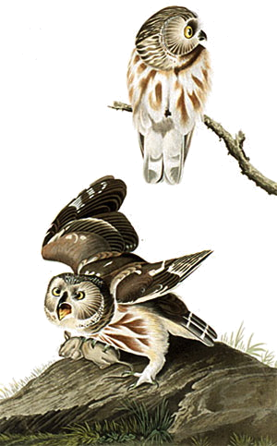
5. Specific problems
The station coordinator and lead owl banding volunteer is in charge and responsible for all decisions to close down operations. Netting should stop if:
- Wind is very strong (e.g. leaves being blown into nets almost as fast as they can be removed).
- Rain or wet snow begins (stronger than drizzle).
- Nets are damaged. (Ensure replacement the next day).
- Predators are present. Shut down until the suspected predator has left the area or been removed (set live trap and transport animal to park’s west boundary).
A bird that is injured and unable to fly should be held overnight. If it has a simple wing sprain, the bird may be released the next night; but if longer rehabilitation is required, it should be transported to Dr. Reed Veterinary clinic at US 20 and Waverly Road.

6. Closing down
Furl nets and put on at least 3 ties to hold in place. Raise nets to at least six feet high to avoid them having deer hit them. Return broadcast equipment to banding Nature Center if needed. Attach FoxPro to charger. Return any bags, knives, and knitting pins to supply box at net site. Return any borrowed head lamps to Nature Center.
By the end of the night or the next morning, report to the project coordinator any difficulties with broadcast equipment, nets, headlamps or any other equipment, and any shortage of banding supplies.
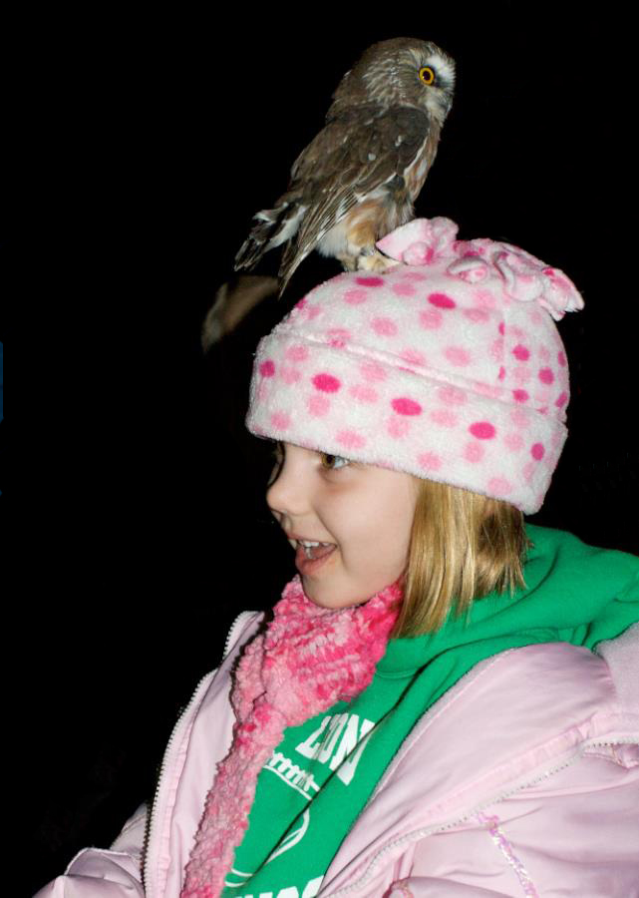
7. Public Interaction
The Saw-whet Owl project is a primary research facility for migrating owls in the Indiana Dunes area. It is the only station conducting regular owl banding in all of Northern Indiana as well. A secondary goal is to educate the public on these fascinating birds. Volunteers are expected to engage with the public that may be visiting the Nature Center, whether during an official public night or an informal night. Aside from basic needs and privacy, most volunteers should choose to “hang out” in the auditorium to answer public questions.
Much of the funding for the project comes from our visitors adopting owls or purchasing goods at the Nature Center gift shop. All volunteers should be able to make quick sales or to be able to assist in an owl adoptions.
If during a very busy public night, it is expected that if needed, a volunteer stay back to assist with the public in adoptions or sales if needed.

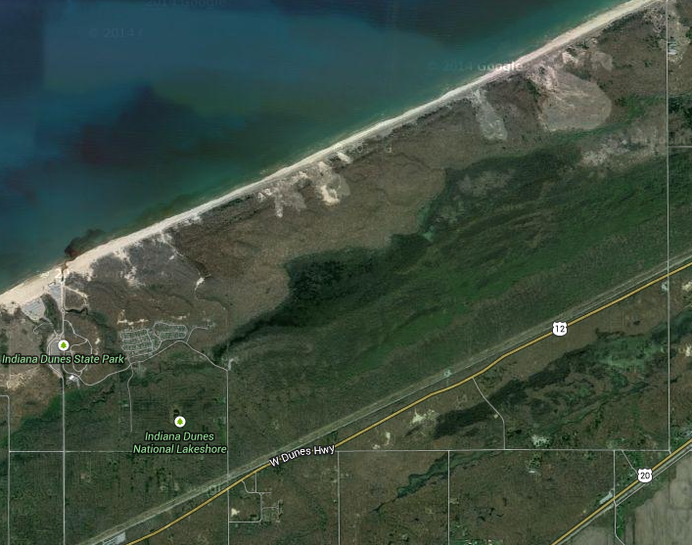
Figure 1: Overall Site Map

Paradise Substation
Nature Center (Banding Site)

Banding Station

Park Exit

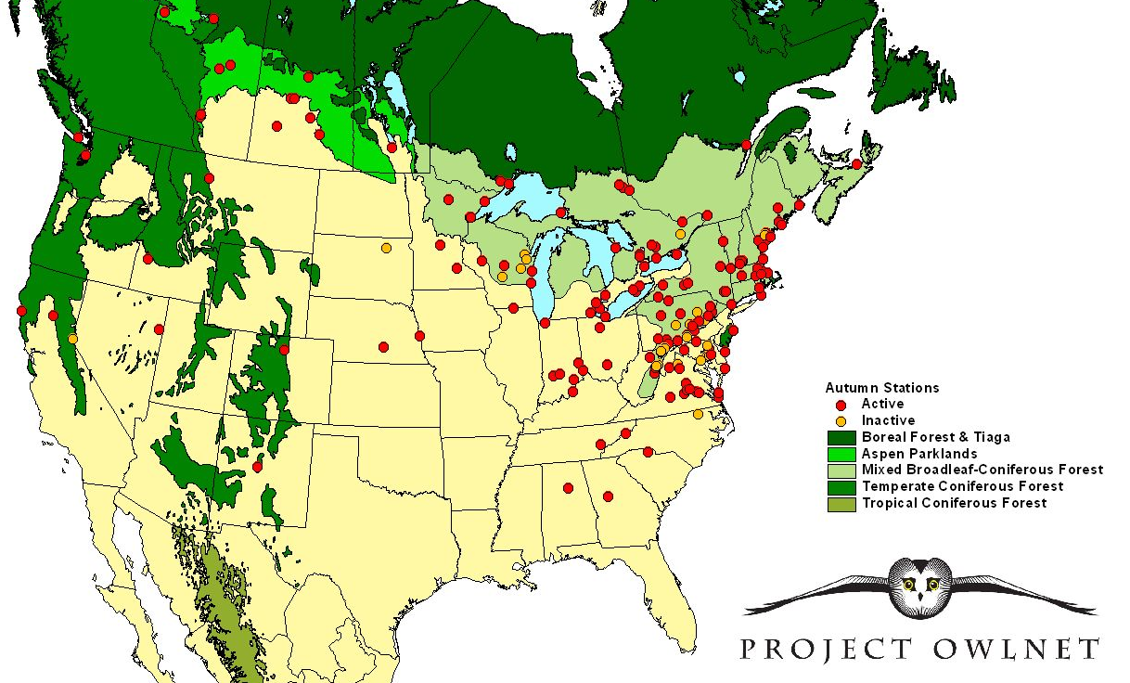
Figure 2: Project Owl Net Stations

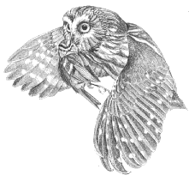
Figure 3: Example Adopt an Owl Form
Indiana Dunes State Park
Saw-whet Owl Adoption Program
Supporting research on the migration patterns
of the Northern Saw-whet Owl in the Indiana Dunes.
__ Yes, I would like to support Saw-whet Owl research and other NIMBA Projects!
Name: ______________________________________________________________
Address: ____________________________________________________________
City: __________________________ State: ______________ Zip: _____________
Phone: ________________________ Email: _______________________________
___Yes ___ No Others (school classes, individuals, etc…) may also adopt my owl to assist in fundraising to support this research.
Send a check with $25 for each Northwest Indiana Migratory Bird Association
Adopted owl payable to: 1600 N 25 E
Chesterton, IN 46304

